**Q2) Generate a model in Python to represent a Housing loan scheme and create a chart to**

**display the Emi based on rate of interest and reducing balance for a given period. If a customer**

**wishes to close the loan earlier, print the interest lost distributed over the remaining no. Of**

**months. Assume suitable data and inputs as necessary.  
  
Code:**

import matplotlib.pyplot as plt

class HousingLoan:

    def __init__(self, principal, interest_rate, tenure):

        self.principal = principal

        self.interest_rate = interest_rate / 100

        self.tenure = tenure  # in months

    def calculate_emi(self):

        r = self.interest_rate / 12

        emi = (self.principal * r * ((1 + r) ** self.tenure)) / (((1 + r) ** self.tenure) - 1)

        return emi

    def early_closure(self, remaining_months):

        total_interest_saved = self.calculate_emi() * remaining_months - (self.principal * remaining_months / self.tenure)

        return total_interest_saved

loan = HousingLoan(500000, 7, 240)  # Principal, interest rate, tenure (in months)

emi = loan.calculate_emi()

print(f"Monthly EMI: {emi:.2f}")

remaining_months = 120

interest_lost = loan.early_closure(remaining_months)

print(f"Interest saved if closed in {remaining_months} months: {interest_lost:.2f}")

interest_rates = range(5, 11)

emis = [HousingLoan(500000, rate, 240).calculate_emi() for rate in interest_rates]

plt.plot(interest_rates, emis)

plt.title('EMI vs Interest Rate')

plt.xlabel('Interest Rate (%)')

plt.ylabel('EMI Amount')

plt.grid(True)

plt.show()

**Output:**

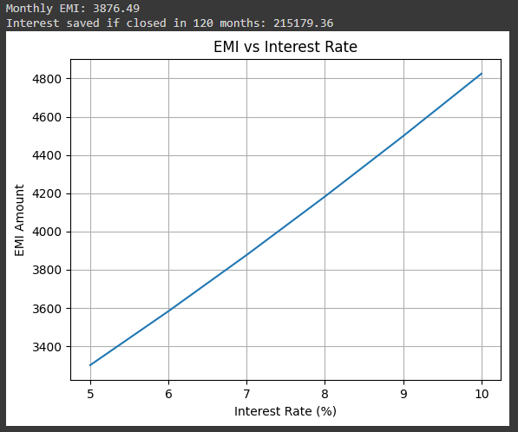

**Q6 Generate a model to represent a mathematical equation, write a program to parse the**

**equation, and ask for input for each parameter.**

**Code:**

import sympy as sp

def parse_equation(equation_str):

    equation = sp.sympify(equation_str)

    return equation

equation_str = input("Enter a mathematical equation: ")

equation = parse_equation(equation_str)

variables = equation.free_symbols

values = {}

for var in variables:

    values[var] = float(input(f"Enter value for {var}: "))

result = equation.subs(values)

print(f"The result of the equation is: {result}")

**Output:**

